1. Access 1b - Drafting the Scene drop box

2. Make sure it’s on “All participants” for “visible groups” and click view all submissions

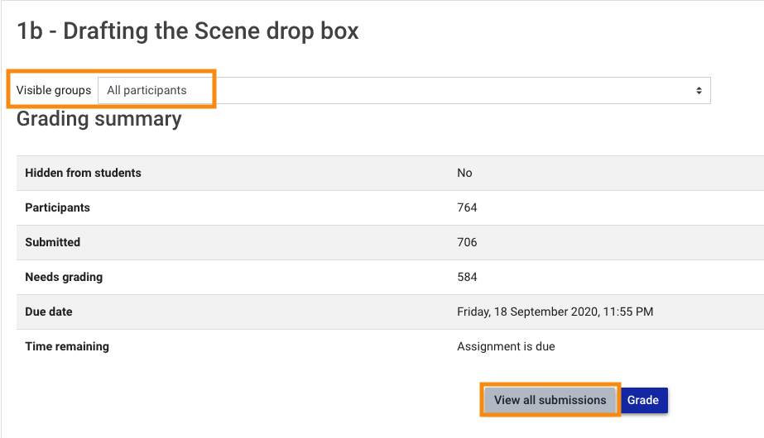

3. In new window scroll to the bottom and change “marker filter” to your name. Make sure none of the other filters here are on (they should say no filter)

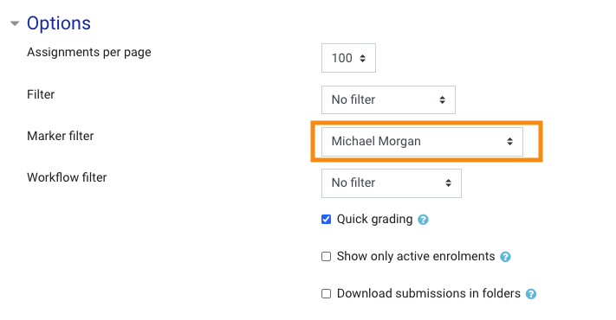

4. You should then have the following view. If you don’t there should be a reset table preferences option at the top on the RHS
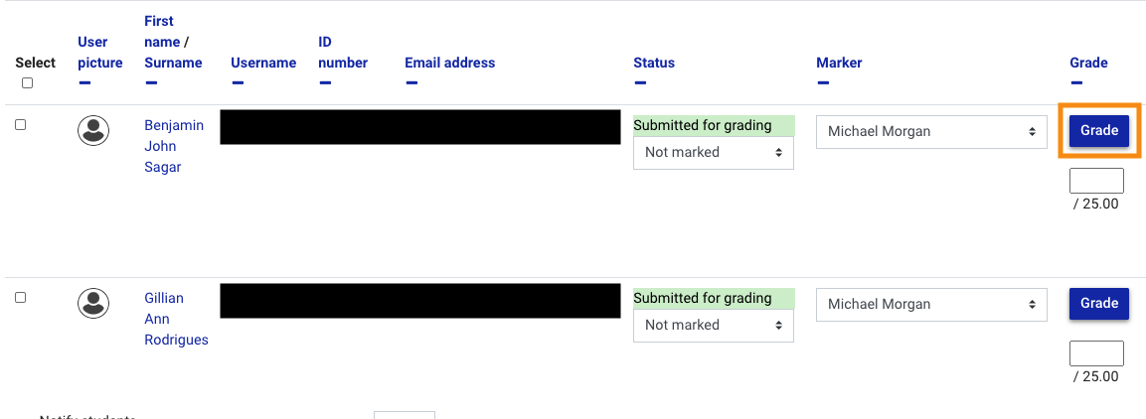

5. Click grade for the student whose word doc you have annotated/marked.
6. Add grade and change marking workflow state 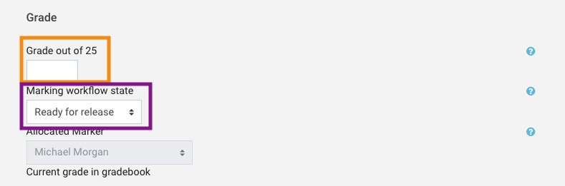

Scroll down on same screen and upload word doc 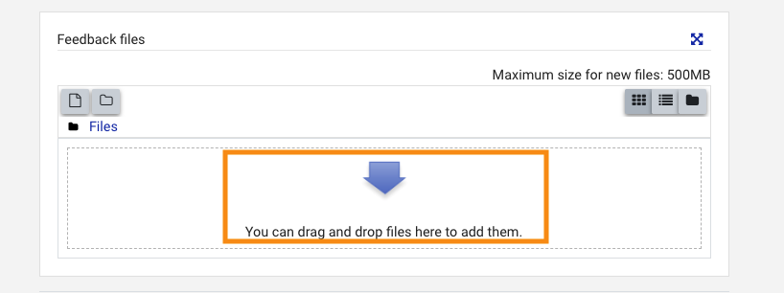

Just below file upload click “Save changes” 